27.72: a)
b) The net force on the triangular loop of wire is zero.
c) For calculating torque on a uniform wire we can assume that the force on a wire is applied at the wire’s center. Also, note that we are finding the torque with respect to the PR-axis (not about a point), and consequently the lever arm will be the distance from the wire’s center to the x-axis.

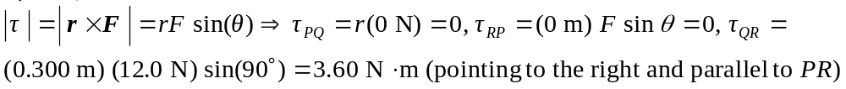
d) According to Eqn.
which agrees with part (c).
e) The point Q will be rotated out of the plane of the figure.

